**Assignment - 3**

**What is Maltego tool?**

Maltego is a data visualization and link analysis tool used for gathering and analyzing information on individuals, organizations, and networks. It can be used for various purposes such as intelligence gathering, digital forensics, and information security investigations. Maltego allows users to gather information from various sources such as social media, public records, and online databases, and then visualize and analyze the connections and relationships between different pieces of information. The software can also be used to identify potential vulnerabilities and security threats. Maltego is widely used by law enforcement agencies, security professionals, and intelligence analysts.

* Maltego is proprietary software created by Paterva Ltd [4], a company based in South Africa.
* It is currently managed by Maltego Technologies, which is a German company.
* Maltego is an open-source intelligence (OSINT) and graphical link analysis tool for gathering and connecting information for investigative tasks.
* Maltego is used to map the relationships between pieces of information. It uses Entities and Transforms.

**Installation:**

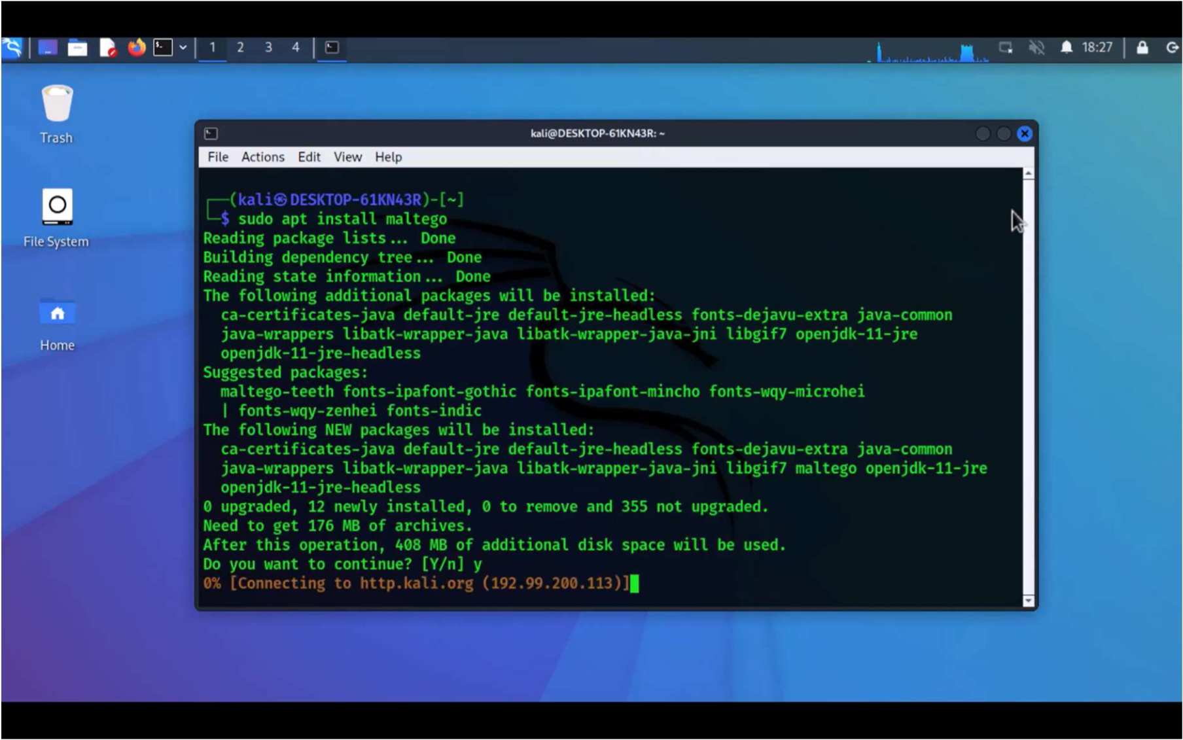

**Opening Maltego:**

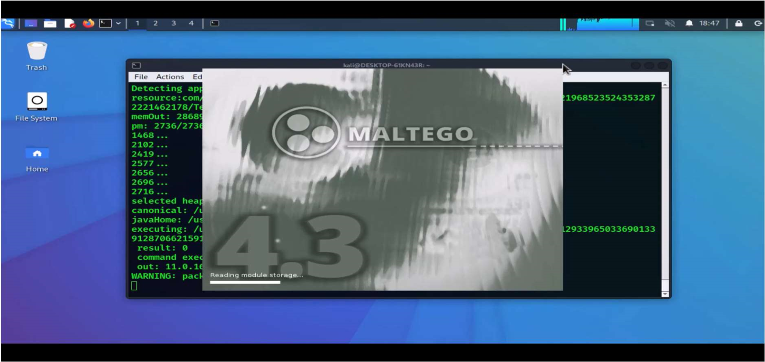

**Home Page:**

